Panther Help

**PANTHER THEME INSTALLATION**

Click “Appearance” – “Themes” – “Add New” – “Upload Theme” and choose Panther theme zip package, and click “Open” then “Install Now”

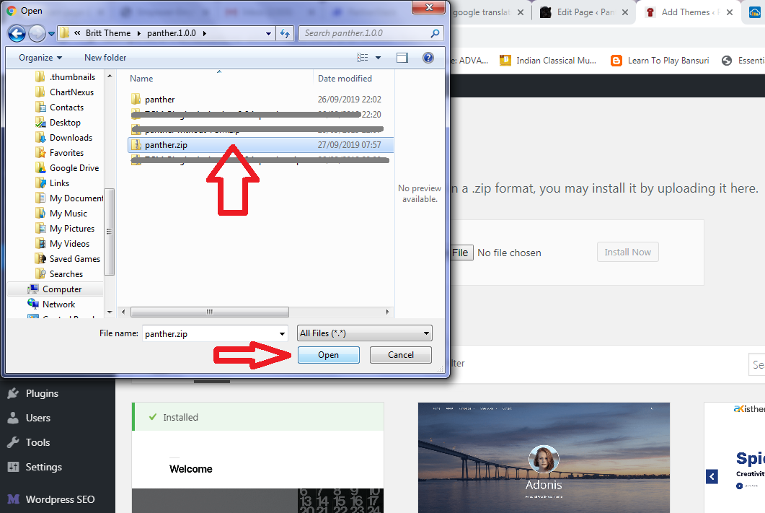

Then “Return to themes page” and view installed Panther theme at “Appearance” – “Themes”

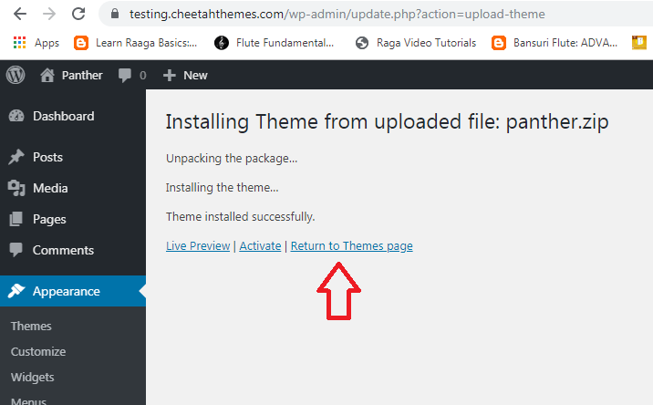

Hover the mouse on the Panther theme and choose “Activate” to activate the Panther theme.

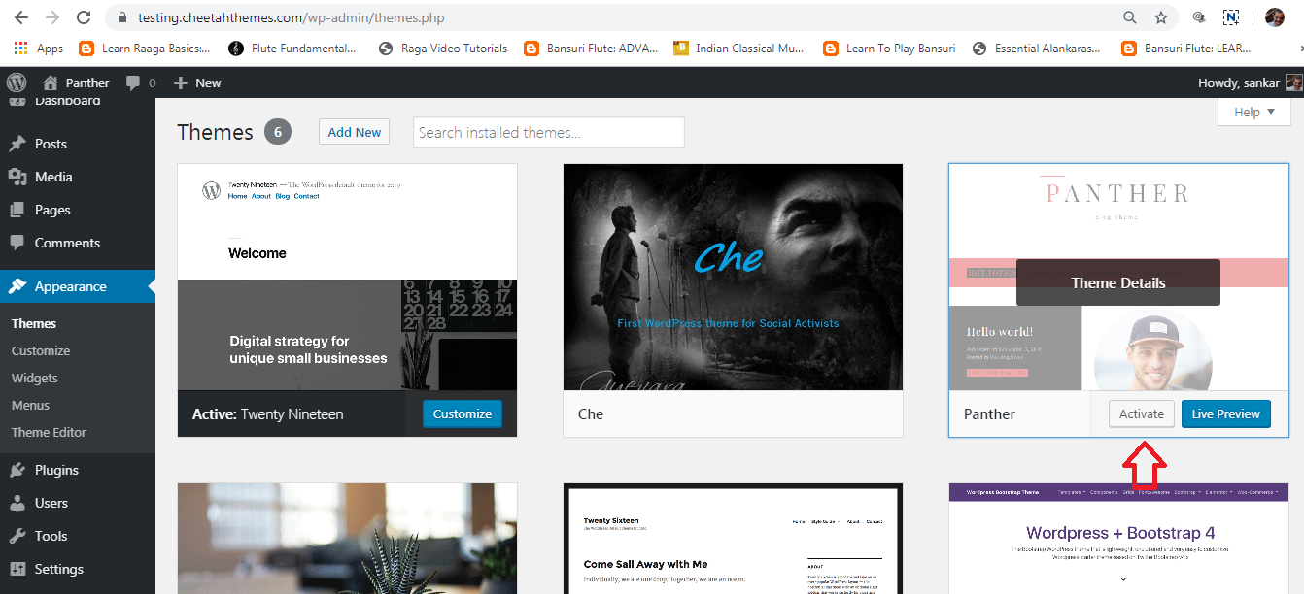

Now, Panther theme was activated. The screen looks like this. This theme recommends a email newsletter plugin. There is no monthly subscription. It is working with WordPress mail functions. If you wish, you can install this plugin. Otherwise, you can use your existing email service.

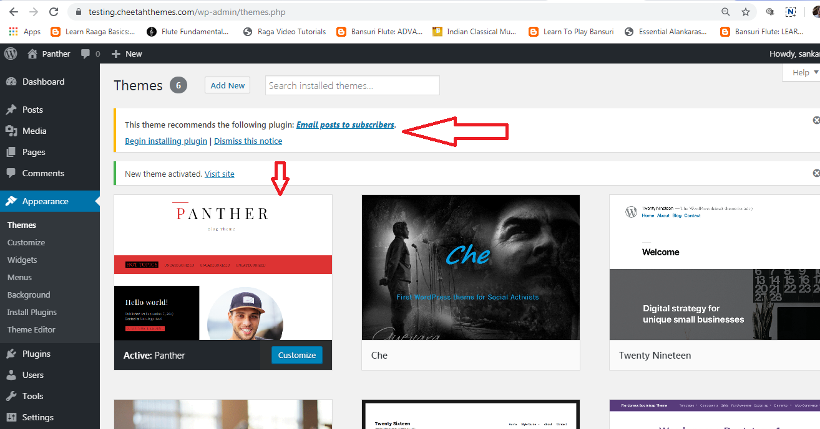

After installing Panther theme, visit your website.

If you want to continue this Panther theme with your existing blog posts, you can continue. Otherwise, write new blog posts.

**CUSTOMIZATION**

It is time to customize the Panther theme upto your need. You can add the following, or your own.

**CAROUSEL**

Click “Appearance” – “Customize” – “Carousel”. Carousel is nothing but slider effect of one or few of your blog posts, to attract the readers.

* Default carousel title is “Latest News”. You can edit it.
* Then go to post IDs.

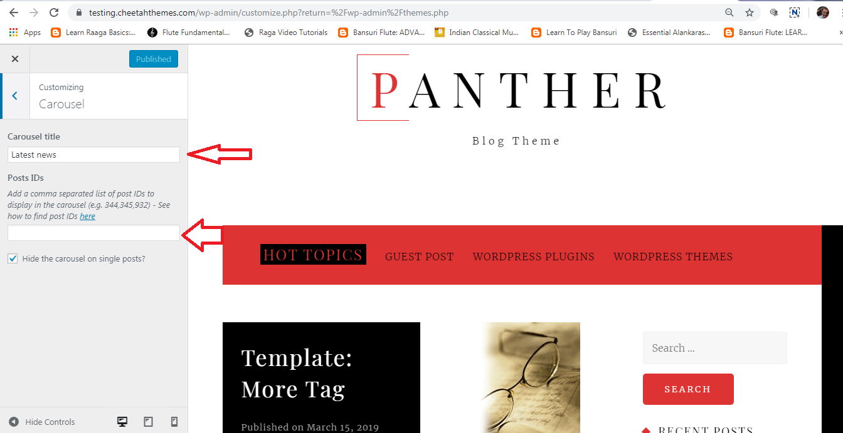

You can enter comma separated post IDs to make carousal effect. How to find post IDs? Go to “Posts” – “All Posts” – hover your mouse to the title of the blog and find post id at bottom side.

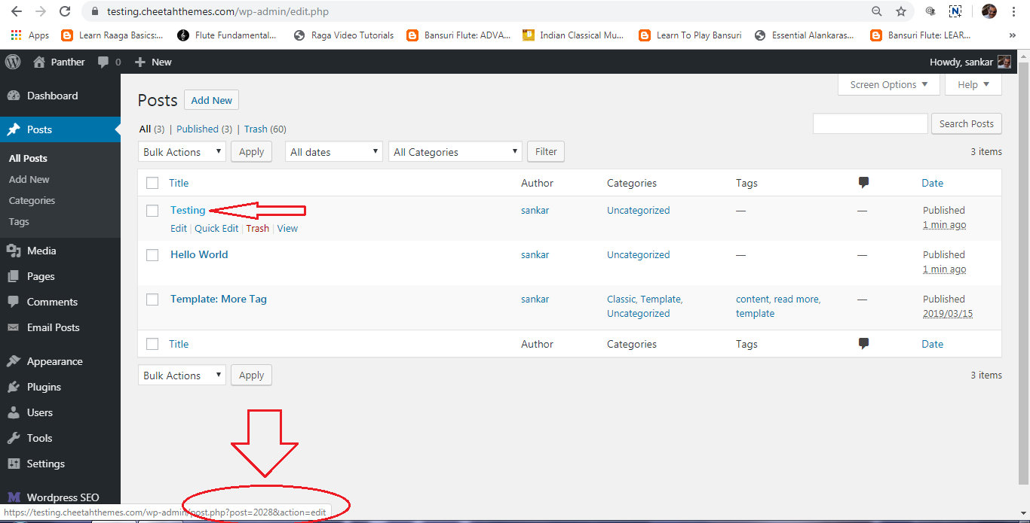

Find post IDs of your required posts and enter them in “Post IDs” option. Now, your carousal looks like this.

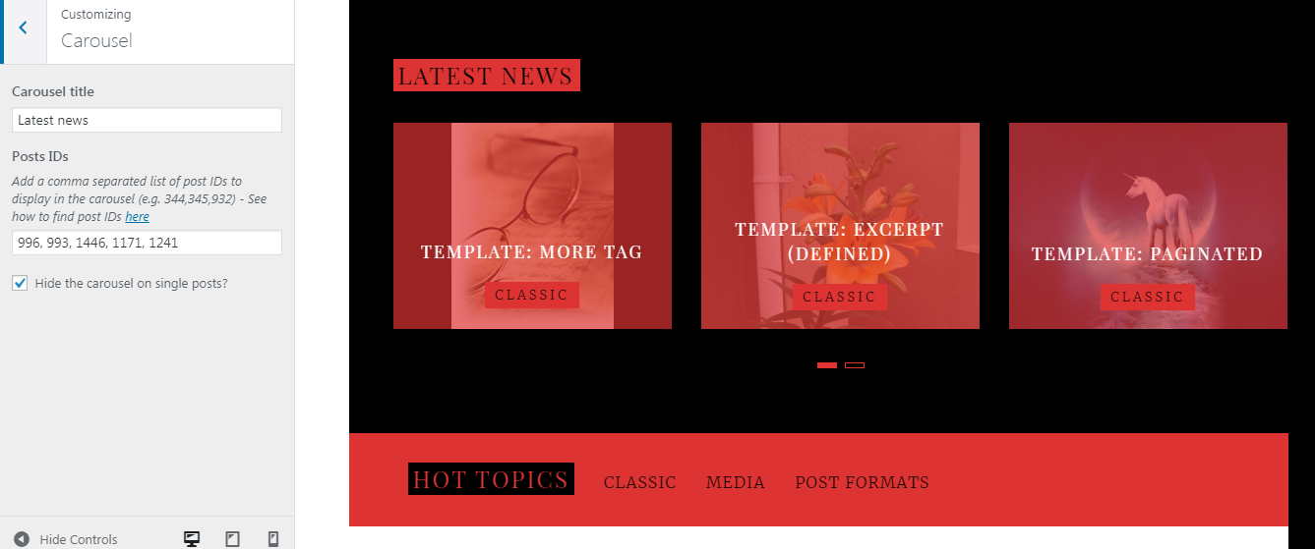

It automatically scrolls once your enter more than 3 post IDs.

**FEATURED CATEGORIES**

Here, you can choose your blog post categories to be featured. Click “Featured categories” and choose 3 categories. “Hot Topics” is default heading. You can change it.

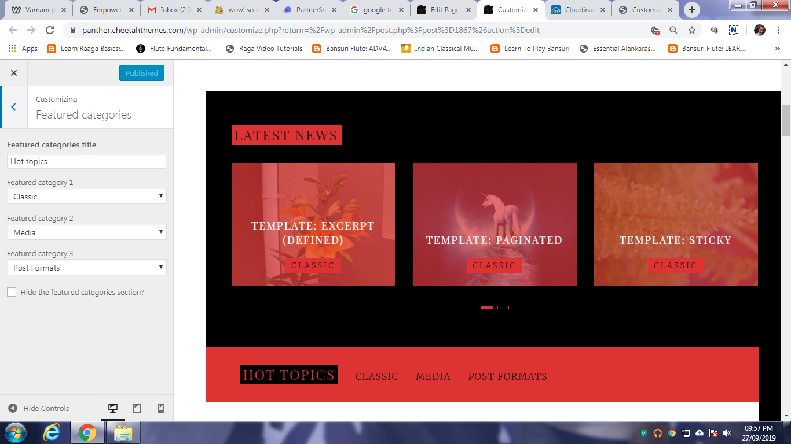

**BLOG**

Click “Blog” and find options to display blog posts with images. Make required changes, if any. Then come to “Call to Action area”. This is a ribbon after first 2 posts. You can link your another website or some other sites with explanation.

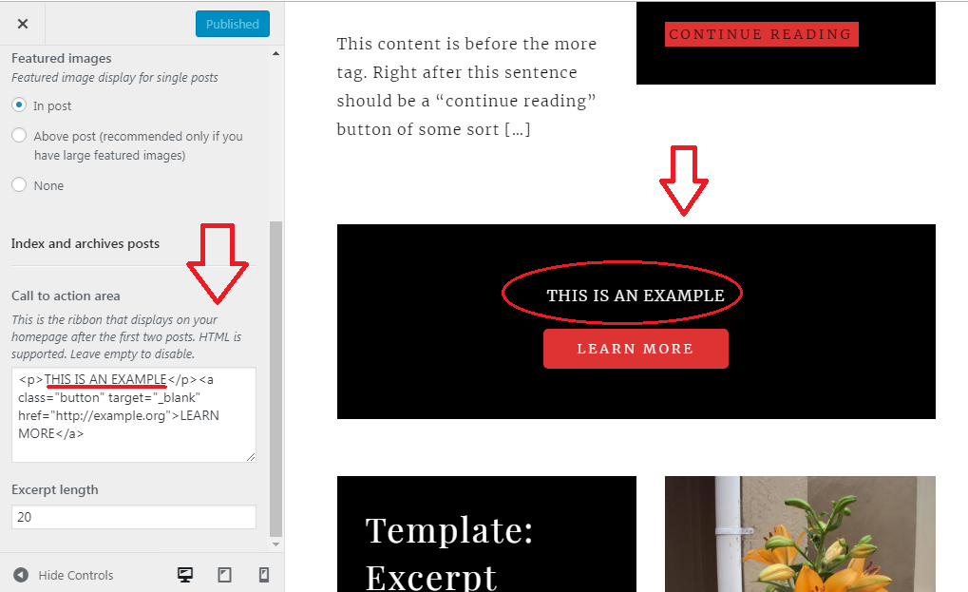

**FONTS**

If you are well versed in Google Fonts, directly download your favourite google fonts and make changes in the “Fonts” option. Otherwise, hire a developer to do this. If you don’t like to change the font, just leave it.

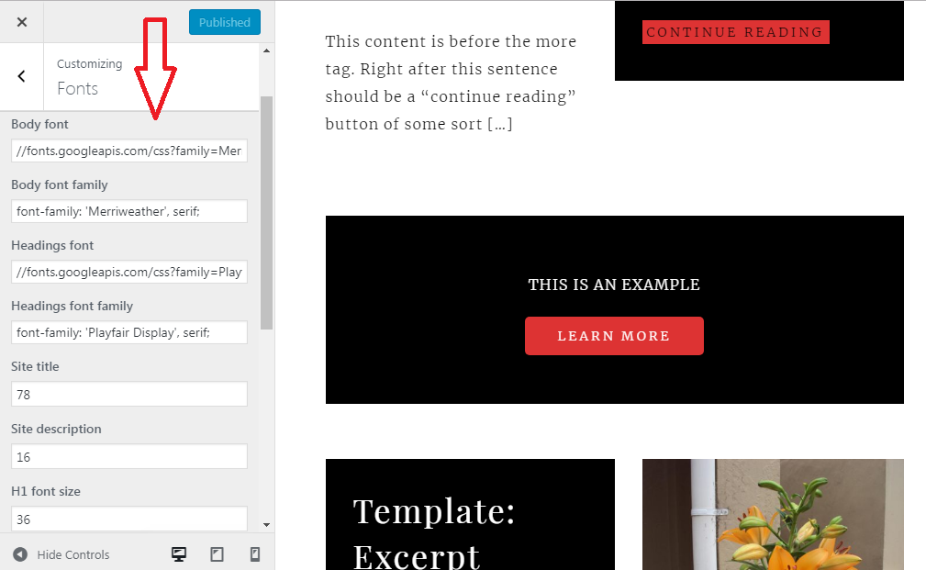

**SITE IDENTITY**

Add “Logo”, “Site Title”, “Tagline” and “Site Icon” related with your websites.

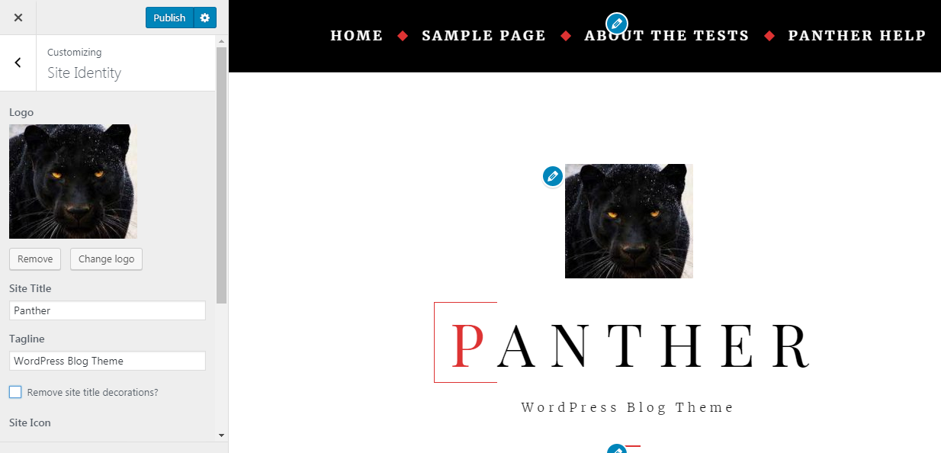

**COLORS**

Here, you can change required colors of your choice.

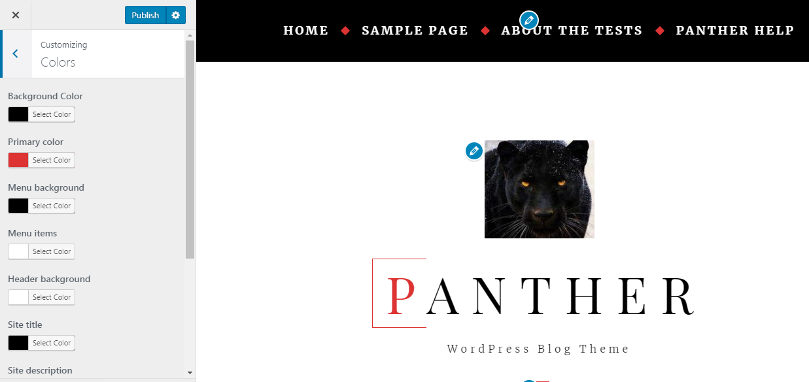

**BACKGROUND IMAGE**

You can set background image here, if you wish.

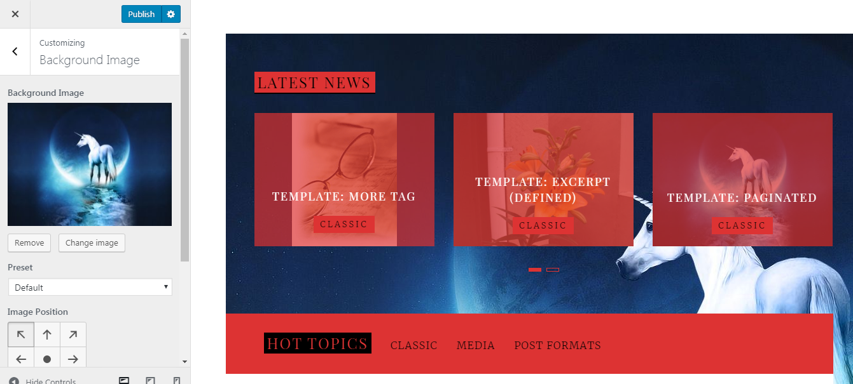

**MENUS**

This theme supports 2 menus. You can edit as per your need.

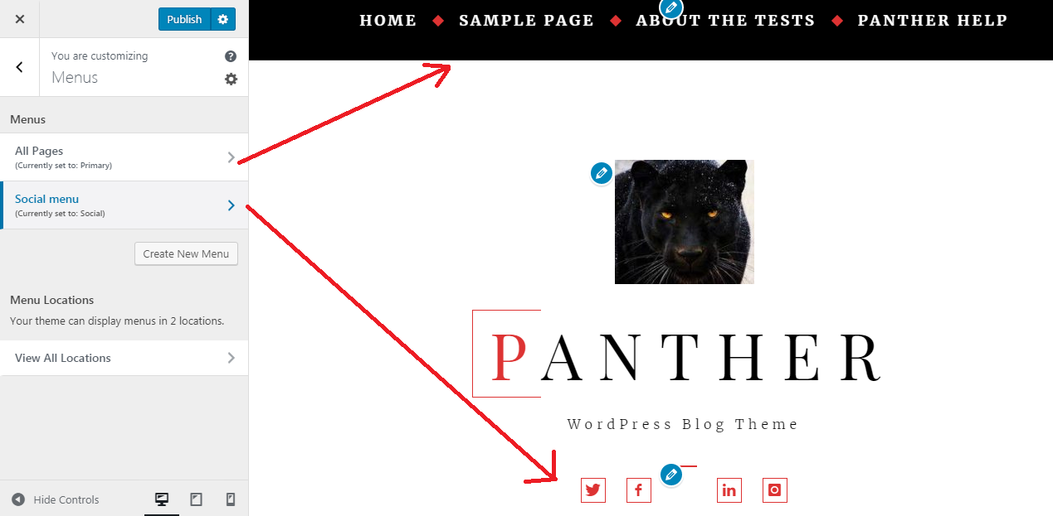

**WIDGETS**

This theme comes with 3 in-built widgets, 1) About Me 2) Intro Video and 3) Recent Posts.

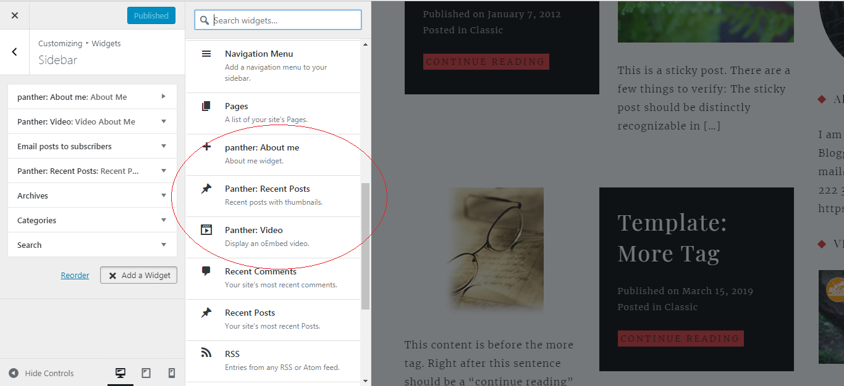

About Me – Click “Add a widget” and choose “Panther: About Me” widget. Fill your details and click “Publish”.

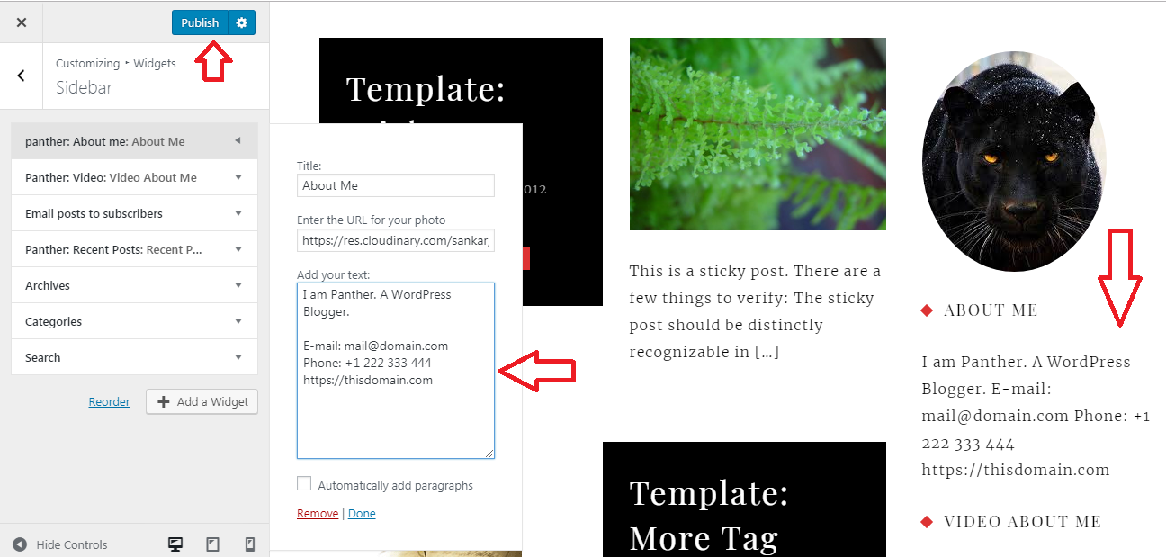

Video – Click “Add a widget ” – “Panther : Video” and add video about you or about your project. This theme supports youtube and vimeo videos.

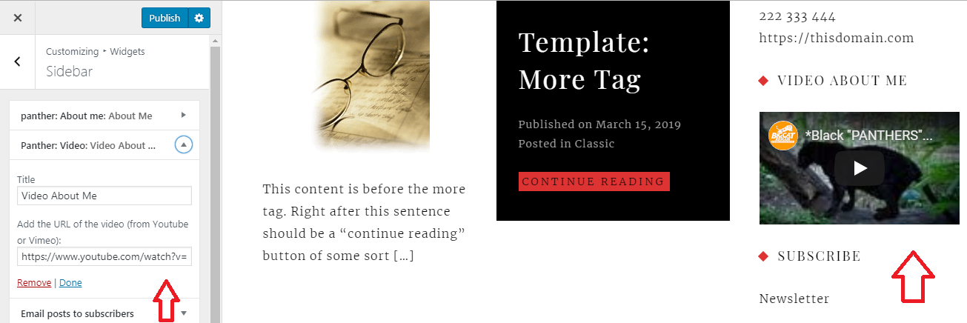

Recent Posts – Click “Add a widget” – “Panther : Recent Posts” and enter number of recent posts you want to display.

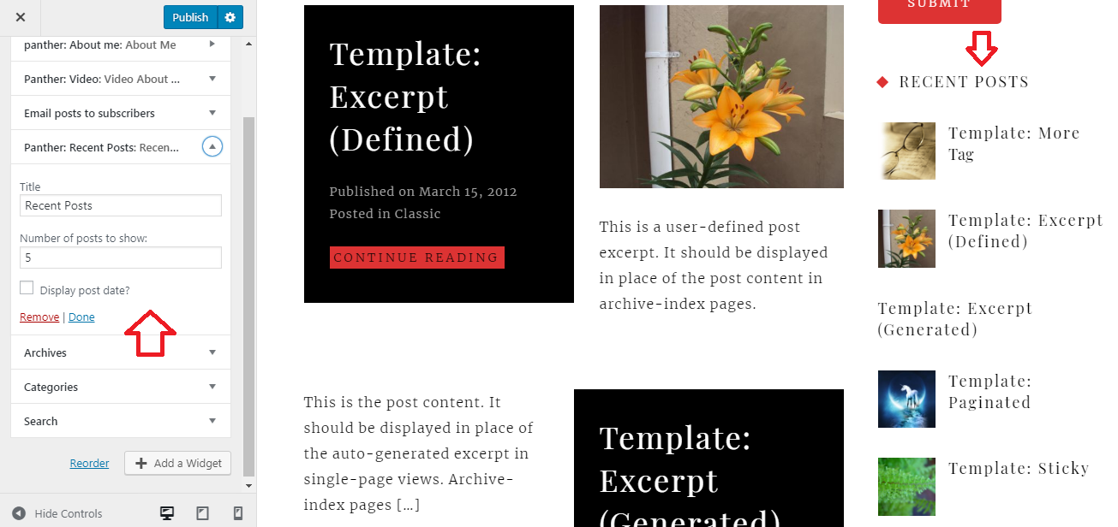

Now, your website is Ready. Later, you can add more pages and build with Gutenburg blocks or Page Builders.

———————————————————————



**SEO** **Optimized (If you want to use SEO Plugin, you can use that. This code cannot affect your plugins.)**

**STEP 1 *(changes needed)* MAKE YOUR URLs SEARCH ENGINE FRIENDLY**

Click “Settings” – “Permalinks” and change “Common Settings” to “Day and Name” or “Month and Name” or “Post Name” (Recommended)

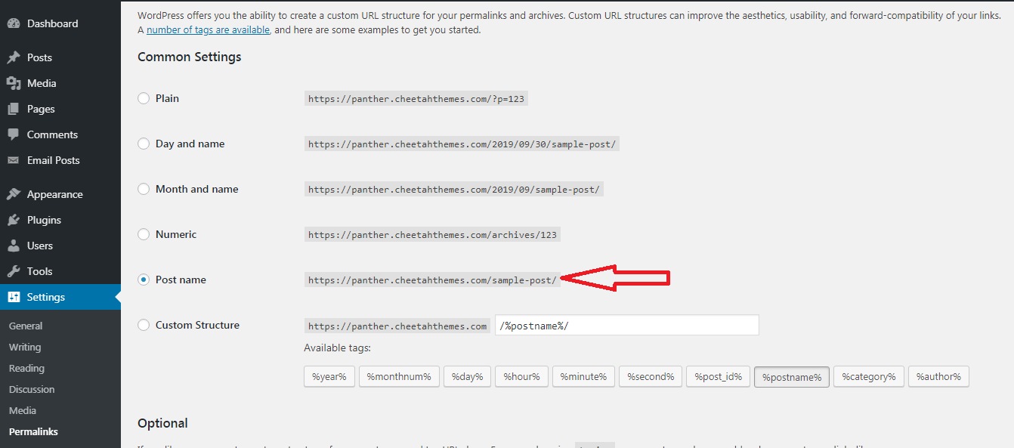

**STEP 2 *(changes needed)***

Now, set your title and tagline. Click “Settings” – “General” and fill “Site Title” (with 60 characters) and “Tagline” (with 160 characters)

**STEP 3 *(NO changes needed)* Title & Meta Description**

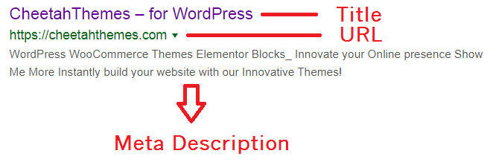

Title and meta description both are important for search results.

**STEP 4 : XML SITEMAP**

An XML sitemap is important for all kind of sites as it helps search engine crawlers to find all the posts, pages, and other links of the site on one page. You need to complete two steps here.

A) First you need to create xml sitemap. XML sitemap is nothing but collection of all links of your website, including pages, posts, images etc.

B) Next submit sitemap to Google Search Console, to index your website to its search results.

**A) CREATE XML SITEMAP**

Visit <http://www.web-site-map.com/xml_sitemap.php> and enter your website address and click “Create FREE XML sitemap”. Follow my example.

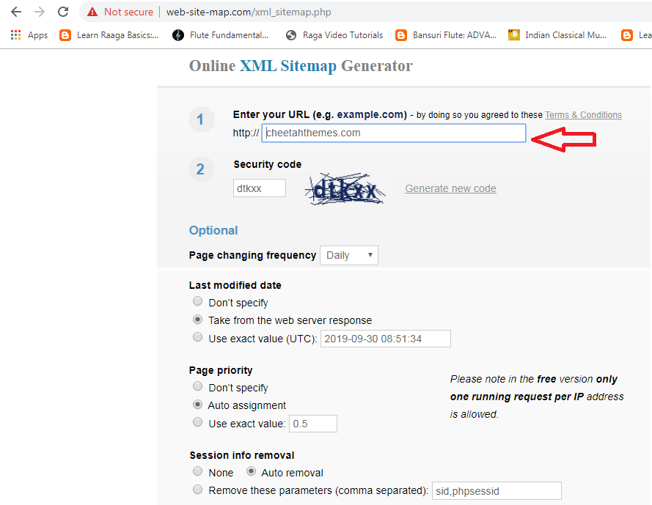

After a moment, your sitemap will be ready to download. Click “Download your sitemap” then click on “download” and store your sitemap.xml file.

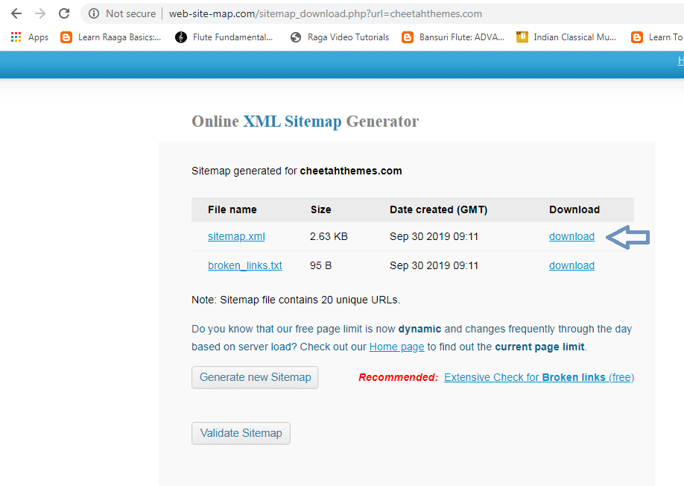

**B) SUBMIT SITEMAP TO GOOGLE SEARCH CONSOLE.**

Visit <https://search.google.com/search-console/about> and click “Start Now”. Login with your google email address and password.

Click on top left corner and choose “Add Property”.

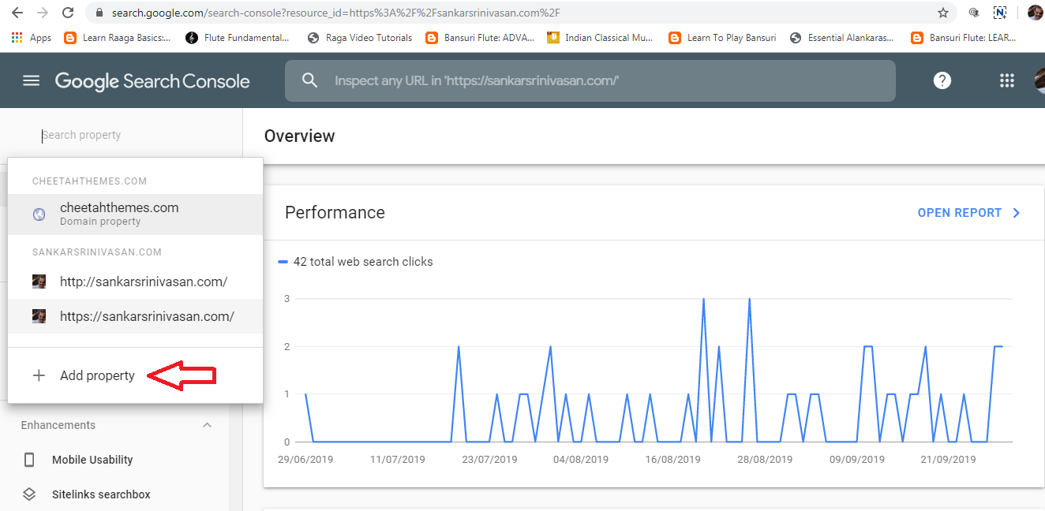

Enter your website URL and click “Continue”. I am testing with my theme URL https://panther.cheetahthemes.com

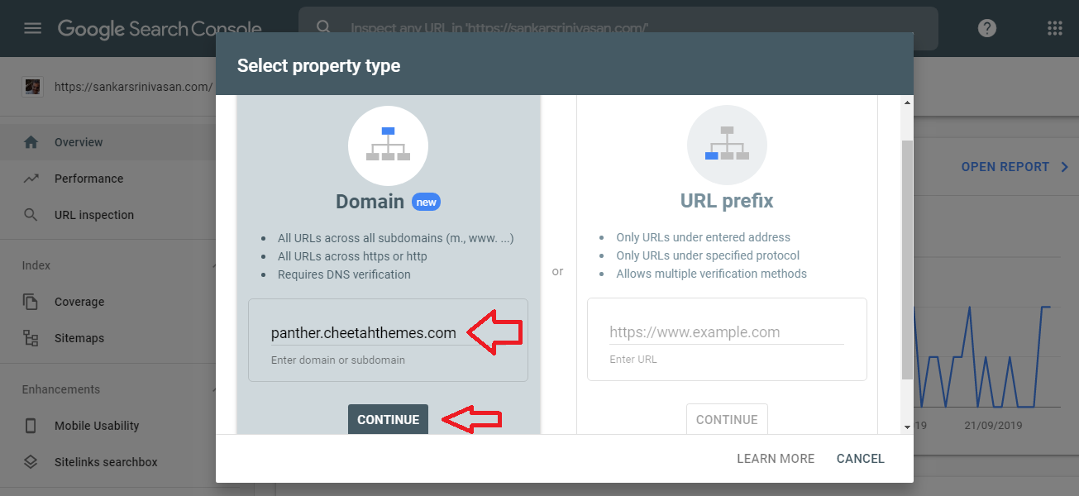

DOMAIN VERIFICATION

Then, Google Search Console leads you to verify your domain ownership. Do that, as per instructions.

UPLOAD SITEMAP.XML

Then, upload your downloaded sitemap.xml file to root folder of your hosting’s file manager.

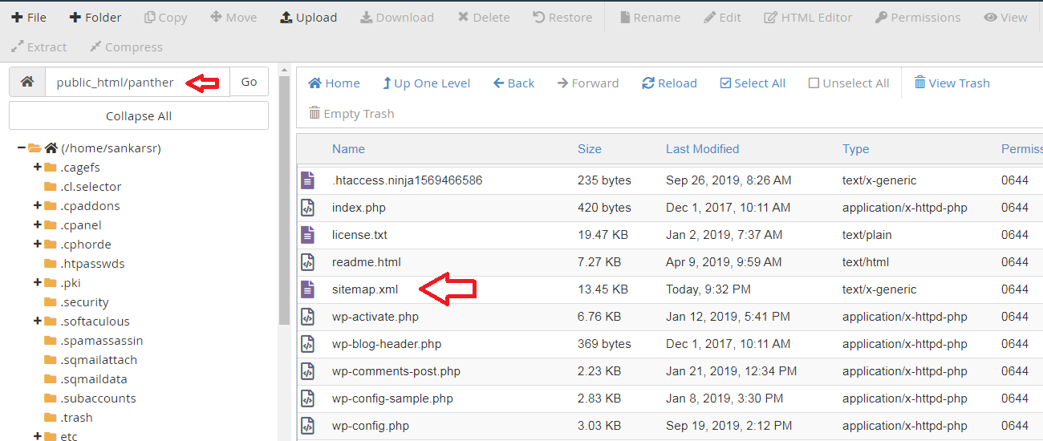

If you uploaded sitemap.xml file in your hosting’s root folder, the URL is yourdomain.com/sitemap.xml

Then, go to Google Search Console again and click on “Sitemaps”, enter above URL of your uploaded sitemap.xml file and “SUBMIT”.

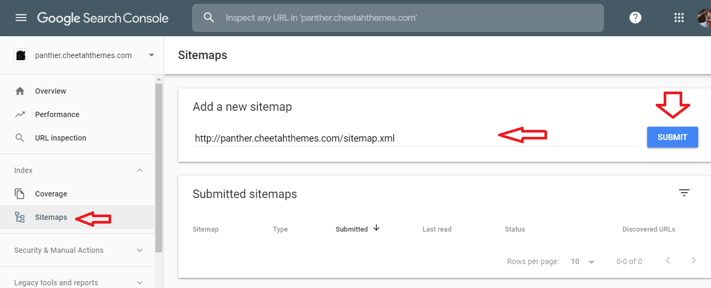

You have submitted sitemap.xml successfully

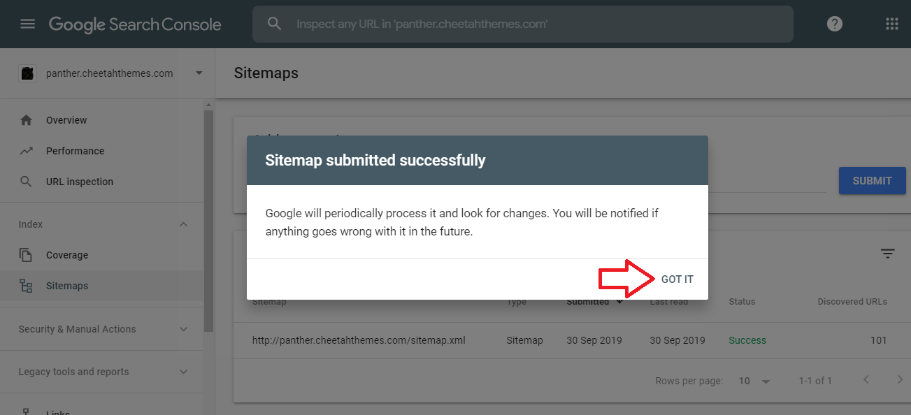

That’s all. You have done a great job…

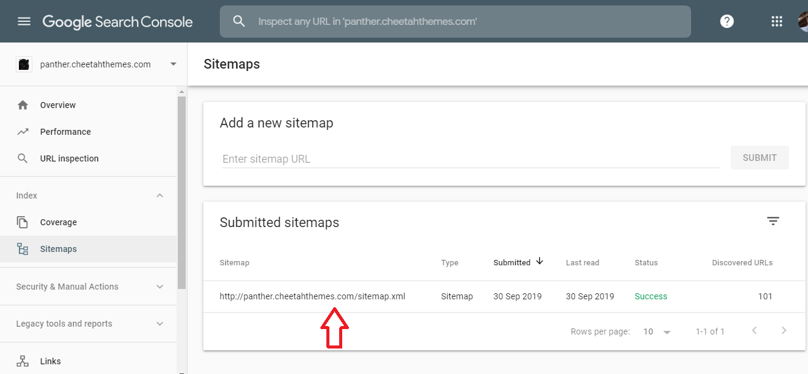

Google take 1 day time to index and crawl URLs of your sitemap.xml. You will get confirmation email from Google Search Console. **SEO configuration works finished.**

**Alternatively, you can do these works with SEO plugins.**

——————————————————————

**TIPS FOR CONTENT OPTIMIZATION FOR BETTER SEARCH RESULTS**

**CONTENT OPTIMIZATION**

When you write the blog contents, remember these points to optimize the content as search engine friendly.

* Include TARGET KEYWORD in the first paragraph & last paragraph of your every blog post
* Include TARGET KEYWORD atleast once in <H2> and once in <H3> tags within the post.
* Use few alternate keywords instead of using the primary target keyword all the time in the post.
* Interlink the content.

**IMAGE OPTIMIZATION**

Images are taking important part in search results. When uploading an image, make sure to enter all columns, particularly “Alt Text”.